**CYBER SECURITY**

**S.DHARANI**

A.V.P. COLLEGE OF ARTS AND SCIENCE

DEPARTMENT OF COMPUTER SCIENCE

**S.DHANIYALAKSHMI**

A.V.P. COLLEGE OF ARTS AND SCIENCE

DEPARTMENT OF COMPUTER SCIENCE

**ABSTRACT**

The internet of India is growing rapidly. There are two sides to a coin. Internet also has its own disadvantages is cyber crime-illegal activity committed on the internet

Cyber security encompasses a broad range of practices, tools and concepts related closely to those of information and operational technology (OT) security. Cyber security is distinctive in its inclusion of the offensive use of information technology to attack adversaries.

Keywords - Internet , India Growing, Cyber, Activity, Cyber security**.**

**CONTENTS:-**

* **INTRODUCTION**
* **HISTORY OF CYBER SECURITY**
* **WHAT IS CYBER SECURITY**
* **HOW DOES CYBER SECURITY WORKS**
* **TYPES OF CYBER SECURITY**
* **ADVANTAGES OF CYBER SECURITY**
* **APPLICATIONS OF CYBER SECURITY**
* **FEATURES**
* **CONCLUSION**

**INTRODUCTION**

Cyber security refers to the technologies and processes designed to product computers, networks and data from unauthorized access and attacks delivered via the internet by cyber criminals though, cyber security is important for the network, data and application security.

The objective of cyber security is to established rules and measure to use against attacks over the internet. Then there are eight threads are there in cloud computing hacking data avoided these threads we are using Cyber security.

**HISTORY OF CYBER SECURITY**

The cyber security checking began in the 1970s when researcher Bob Thomas created a computer program called creeper that could move across ARPANET network. Ray Tomlinson, the innovator of email, wrote the program reaper, which chased and deleted creepers.

**WHAT IS CYBER SECURITY**

* Cyber security is the protection of internet - connected systems, including hardware and software and data, form cyber attacks.
* In a computing context security comprises cyber security and physical securities both are used by enterprises to protect against unauthorized access to data centers and other computerized systems.
* Information security, which is designed to maintain the confidentially, integrity and availability of data, is a subset of cyber security.

**HOW DOES CYBER SECURITY WORK?**

Cyber security is designed to provide multiple layers of protection across all of the computers, networks, and programs used by a business. In order to create a unified defense against potential cyber attacks, it is important that the business, employees, processes, and technology are designed to work seamlessly together. Cyber security systems that function properly. Will be able to detect, investigate, and resolve potential weakness and vulnerabilities in the system before they can be exploited by a hacker or malicious software.

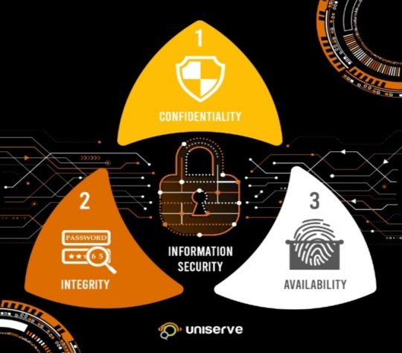**The CIA of information security**

* **Confidentiality:** Ensures that data or an information system is accessed by only an authorized person.
* **Integrity:** Integrity assures that the data or information system can be trusted. Ensures that it edited by only authorized persons and remains in its original state when at rest.
* **Availability:** Data and information systems are available when required.

**TYPES OF CYBER CRIME**

**TYPES OF CYBER CRIME**

**A COMPUTER AS A WEAPON**

**A COMPUTER AS A TARGET**

SPAM EMAIL

PHISHING

DENIAL OF SERVICE

HACKING

ATM SKIMMING AND POINT OF SCALE CRIMES

RANSOMWARE

SPYWARE

MALWARE

**TYPES OF CYBER SECURITY**

**CYBER SECURITY**

**MOBILE SECURITY**

**APPLICATION SECURITY**

**CLOUD SECURITY**

**NETWORK SECURITY**

**DATA SECURITY**

**APPLICATION SECURITY**

**Ap**plication security is the implementation of various defenses with in business software and services to protect against a range of different threads. This type of cyber security requires the design of secure applications to minimize unauthorized access and modification

**DATA SECURITY**

Data security involves implementing strong data storage systems that are specifically designed to secure information while it is being stored and while it is in transit.

**NETWORK SECURITY**

Network security focuses on protecting a business from both external and internal threads by implementing hardware and software systems that are specifically designed to product a business network and infrastructure from misuse, disruptions, and unauthorized access.

**MOBILE SECURITY**

Business that use mobile devices, such as cell phones, laptops, and tablets, should use mobile security measures to protect the information that is being stored on those devices from a range of different threads.

**CLOUD SECURITY**

Most cloud applications and system- AWS, GOOGLE, MICROSOFT, etc use cloud security measures to protect users against various threads.

**ADVANTAGES OF CYBER SECURITY**

* It will defined as from hacks and virus. It helps us to browse the safe website.
* Internet security process all the incoming and outgoing data on our computer
* The cyber security will defined us form critical attacks
* The application of cyber security used in pc needs update every week.
* The security developers will update their database every week once. Hence the new virus also detected.
* It helps to reduce computer chilling and crashes.
* Gives as privacy use.

**APPLICATIONS OF CYBER SECURITY**

Cyber security applications have no limited. There are few applications have below:

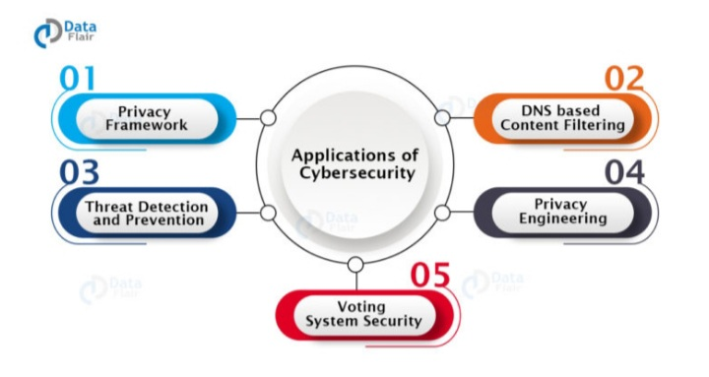

* **Privacy Framework:** It means preventing private data from attackers.
* **DNS-based content filtering:** It means preventing access to websites that harbor malware or ransom ware.
* **Threat detection and prevention:** It means identifying the threat and preventing form the same.
* **Privacy engineering:** It means researching the trust worthiness of cyber technology.
* **Voting system security:** It means having secure voting systems during elections.

**FEATURES OF CYBER SECURITY**

There are many features of there in cyber security

The few features are:

* Coverage for external threads
* Defense against internal threads
* Regulatory compliance for security
* Cloud based security services
* Thread detection, prevention, and response

**CONCLUSION**

Organizations are finding themselves under the pressure of being forced to react quickly to the dynamically increasing number of cyber security threads. Since the attacks have been using an attack life cycles, organization have also been forced to come up with a vulnerability management life cycle.

**REFRENCES**

[ABRAN 2004]

ABRAN, ALAIN, MOORE, JAMES WBOURQUE, PIERRE, TRIPP, LENORD EDS. guide to the software engineering body of knowledge. IEEE computer society.2004

[**www.computer.org/web/swebok/index**](http://www.computer.org/web/swebok/index)

[**www.cybersecurity-wikipedia**](http://www.cybersecurity-wikipedia)

[**www.pptofcybersecurity.com**](http://www.pptofcybersecurity.com)

[**www.cybercrimeimages.img**](http://www.cybercrimeimages.img)

[**www.kyndryl.com/cyber/resilience**](http://www.kyndryl.com/cyber/resilience)

[**www.safety.google**](http://www.safety.google)